4. ReactJS-HOL
Creating React App : npx create-react-app blogapp

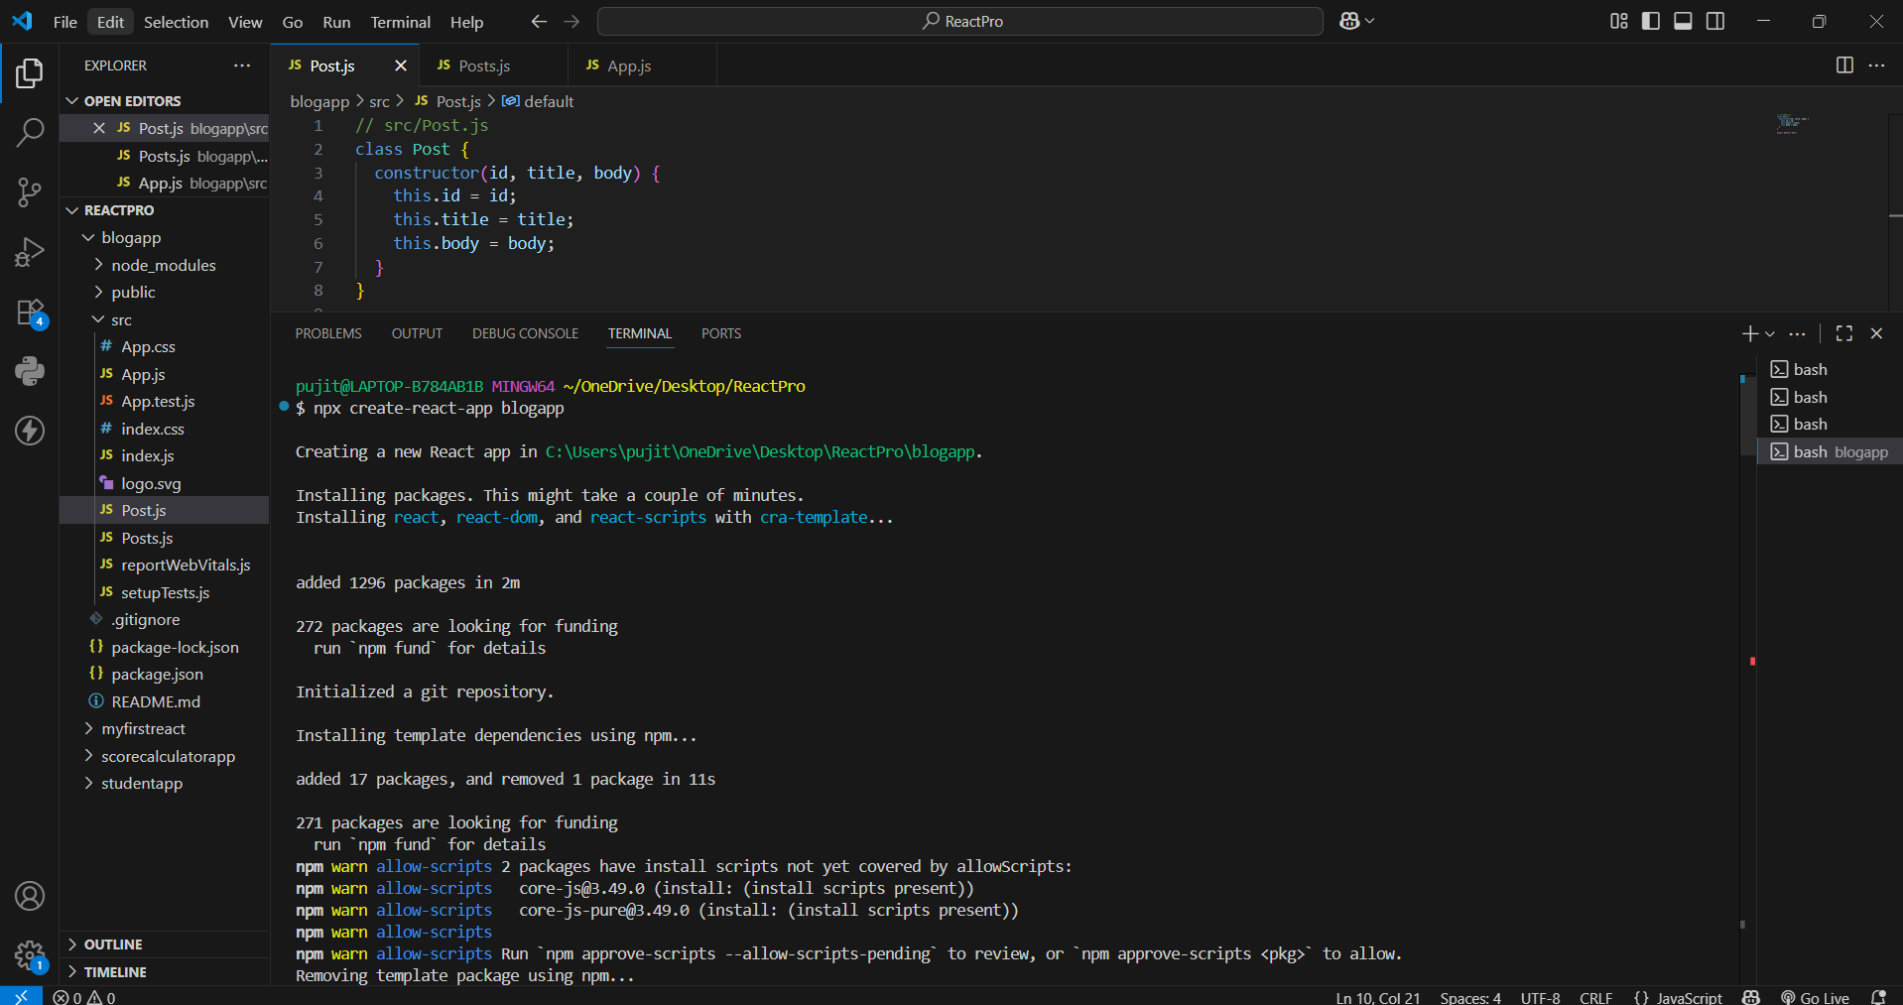
Post.js :
class Post {
constructor(id, title, body) {
this.id = id;
this.title = title;
this.body = body;
}
}
export default Post;

Posts.js :
import React from 'react';
import Post from './Post';

class Posts extends React.Component {
constructor(props) {
super(props);
// Initialize state with an empty array for posts and optional error handling state
this.state = {
posts: [],
hasError: false
};
}

// Fetch posts from JSONPlaceholder API
loadPosts() {
fetch('https://jsonplaceholder.typicode.com/posts')
.then((response) => {
if (!response.ok) {
throw new Error('Failed to fetch posts');
}
return response.json();
})
.then((data) => {
// Map API response items into Post class instances
const postObjects = data.map(
(item) => new Post(item.id, item.title, item.body)
);
this.setState({ posts: postObjects });
})
.catch((error) => {
alert(`Error fetching posts: ${error.message}`);
});
}

// Lifecycle Hook: Triggered immediately after component is mounted
componentDidMount() {
this.loadPosts();
}

// Lifecycle Hook: Catches errors thrown by child components
componentDidCatch(error, info) {
alert(`An error occurred: ${error.toString()}`);
this.setState({ hasError: true });
}

render() {
if (this.state.hasError) {
return <h2>Something went wrong.</h2>;
}

return (
<div style={{ padding: '20px' }}>
<h1>Posts</h1>
{this.state.posts.map((post) => (
<div key={post.id} style={{ marginBottom: '20px' }}>
<h2>{post.title}</h2>
<p>{post.body}</p>
</div>
))}
</div>
);
}
}
export default Posts;

App.js :
import React from 'react';
import Posts from './Posts';
function App() {
return (
<div className="App">
<Posts />
</div>
);
}
export default App;

Running on localhost 3000 :
